**Use GitHub Projects**

**Steal ideas from other apps - use Figma for prototype**

***Scope -*** *Make android app, use cloud-based database, use light sensor on an arduino*

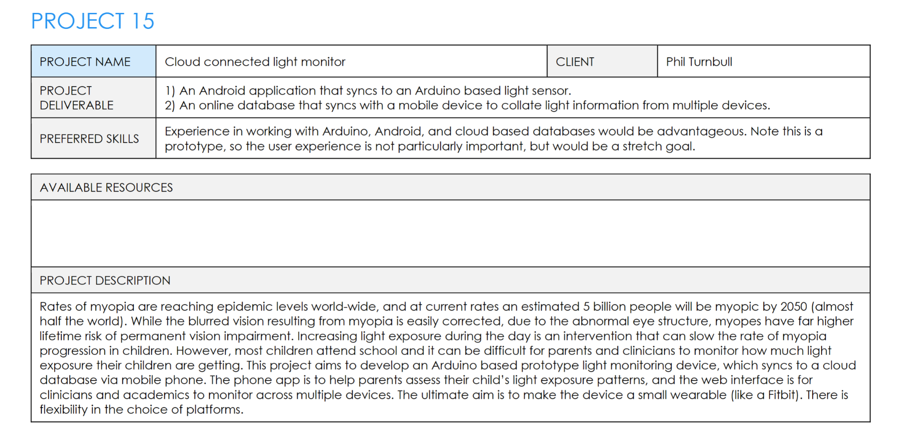

**Client Meeting 1 (6 March 2024)**

Introduce team 🐧

* Specify if only for android or apps that can run in multiple OS…
  + **Android only system for the sensor-phone system**
* What are the technical constraints - specific tools?
* Are there any particular frameworks or languages we should use?
* Technical requirements for the web interface?
  + If not certain- any preferences?
  + **Not much, just legible data tables, stretch goal is having useful UX**
  + **If Database is used, Clients would want a way to navigate this without adequate SQL prowess (*Front end to interact with database (NOT ESSENTIAL to be pretty))***
* Do we make the cloud database from scratch?
* How often would you like to meet? (Every two weeks is recommended for feedback)
  + What mode of communication would you prefer? (e.g zoom)
  + **Client: Weekly to start, communication over email in terms of getting the prototype**
  + **Over Zoom for the next few weeks, possibility of in-person meetings later into the semester (Second half?)**
* Ask the client for an overview of their ideal outcome- what would they like/is most important for the end product to have?
  + MVP: Mobile (Android) App where parents can check the results of childs light sensor. Bare Bones Skeleton where a connection with cloud-based database is a stretch goal
* Is there anything the client DOESN’T want on the project e.g. colours, words, terminology, etc- personal constraints?
* Ask the client if there is anything that could go NOT according to plan (risks)
* How will research regarding light levels be conducted? Provided or something we also need to research?
  + **Most likely research needed, 2 hours sunlight/ outdoors as minimum. Need research to differentiate between indoor and outdoor lighting in sensor**
* Will equipment be provided, such as the arduino and other needed equipment? If not, how will we fund or get them? (Question for lecturer or client)
  + **Client funded**
  + **Arduino for each team**

**Client Meeting 1 Notes (6 March 2024):**

* Even though it'd be better to measure the horizon, it's harder. **So we just need to measure the light level.**
* *Indoors rarely 1000 lux (lux=measure of light)*
* *Outdoors is almost always more than 1000 lux*
* Myopia develops between 8-12 y/o in children

**Problem:** Kids have nearsightedness which can be caused by going outside and parents don't know how much is a healthy amount of time to be outside.

* Myopia - Nearsightedness
* UV sensor/light sensor
* Is device indoors or outdoors (find a way to differentiate indoor/outdoor then get sensor to send a signal to app)
* 2 hours per day OUTDOORS to help with Myopia (in Children???)
* Develop a software that allows parent phones to receive information from the lightmeter worn on a child’s wrist
* Login System For parent to know any trends or indoor outdoor activity

**Ideas**:

* **UV sensor**/light sensor
* Arudino syncs to device via cloud
* Export function
* Parent Login - Different levels of users.
  + Not real time but syncs at the end of the day (5:00 pm?)
  + Everyday data isn’t necessary, end of week can be better
* Bluetooth instead of wifi - for battery life
* *Using two sensors to calibrate a model (Two channels of input)*
* *Event based change in light level (Way to detect a change in light levels, ping, and record)*
* ???Sensor to detect if on wrist???
* Sleep mode while not in motion

**MVP:** Cloud is not essential Mobile App (**ANDROID PHONE APP IS CLIENT PREFERENCE**) that parents can check the results of light sensor

* + Need prototype of the device -> Main priority

**HOMEWORK: RESEARCH WHAT THE BEST HARDWARE WOULD BE FOR THIS  
 CHALLENGE**

**Meeting 2 (13th March):**

**Notes:**

* Fitbit app level insights - high level info and then lower level
* Multi level users

**Questions:**

* We are planning to make an app that parents can use to get updates on their child’s outdoor hours. Do you have a vision for this sort of app in mind?
  + Colour
  + Weekly updates
  + UV
* Application for researchers
* ?
* Sensor on clothing perhaps, rather than wrist
* Reading sensor on phone - more important
* Commercialisation - patent is already there

Weekly to daily

**Meeting 3 (20th March):**

**Notes:**

* ““Will it need a wifi connection?” We want to cut off as many modules as possible.“
  + We could use a bluetooth connection to phone and use the phone’s internet
* Completion circle, like apple fitness
* Self examination of the issues with our solution
* User authentication
  + Account sign-in
  + Local user names
  + Store hashes
  + If researcher login, Decrypt user information

**Questions:**

**To Do:**

* Create a scenario to outline the steps out solution would follow.

**Meeting 4 (26th March):**

**Talking points:**

* What are your thoughts on the stats pages?

**Questions:**

* Would 2 hours a day be a checkmark amount or should the achievement time be different?
* What are your thoughts on the stats pages?
  + Between the daily, weekly, monthly and yearly views do you think the formatting is good?
  + Is it easy to read,
  + Does it cover the information you would like?
  + Are there any changes you would like to make?